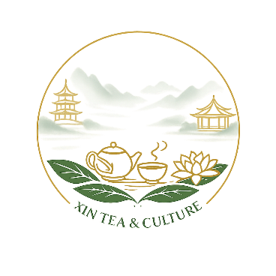
Corporate Team-Building Kungfu Tea Experience （60-90mins）
Transform Team Dynamics Through Mindful Tea Culture
Team-Building Objectives
- Stress Reduction – Slow down the pace, release work pressure, and create a calm, restorative shared experience
- Communication – Encourage open conversation through guided tasting, observation, and shared reflection
- Focus & Mindfulness – Develop attention and presence through observing tea preparation and sensory awareness
Programme Description
This Kungfu tea experience is designed as a corporate team-building activity that combines Chinese tea culture with relaxation, communication, and mindful focus. Through tea demonstration, guided tasting, and light interaction, participants step out of daily work routines and reconnect with themselves and their team.
Depending on group size and objectives, the programme may include:
Program Flow (60–90 min)
- An introduction to Chinese tea culture and the philosophy of Kungfu tea, highlighting balance, focus, and respect
- A live Kungfu tea demonstration by the tea host, introducing the flow, rhythm, and etiquette of tea-making
- An overview of selected Chinese teas—such as green, white, oolong, black (red), and fermented teas—chosen to suit the team’s energy level
- Storytelling around tea origins and craftsmanship, connecting tea culture with values such as patience and collaboration
- A guided tea tasting session, encouraging participants to share sensory impressions and reflections
- Light interactive elements to promote participation and team connection

Why This Experience?
- Unique & Memorable – Break away from conventional corporate activities with an immersive cultural journey
- Mindfulness & Focus – Tea rituals cultivate presence, patience, and deliberate action
- Enhanced Collaboration – Guided tasting and observation exercises promote dialogue and empathy
- Customizable & Premium – Tailor teas, presentation, and themes to align with your company culture
- Wellness & Stress Relief – Provides a calm, restorative pause for high-pressure teams

Step | Duration | Activity
1 | 5–10 min | Welcome & Icebreaker
2 | 10 min | Tea Philosophy & Mindful Leadership
3 | 20–25 min | Live Kungfu Tea Demonstration
4 | 20–25 min | Guided Tea Tasting & Interactive Reflection
5 | 5–10 min | Closing & Team Insights
Commercial Value & Customization
- High-end, experiential team-building for executives, VIP clients, or annual events
- Align experience with company brand or event theme
- Combines wellness + soft skills training in one immersive session
- Optional professional photography/video documentation
Expected Outcomes
- Stronger team cohesion and morale
- Improved focus, patience, and collaborative thinking
- Memorable, high-end corporate experience
- Enhanced brand perception and internal engagement

